**Object Oriented Programming Lab**

**Fall’20**

**Department of Computer Science**

|  |  |
| --- | --- |
| **STUDENT NAME** | Abdullah Muhammad Ibrahim |
| **STUDENT ID** | SP20-BSCS-0027 |
| **SECTION** | AM |
| **ASSIGNMENT NO.** | 09 |
| **DUE DATE** | 27/12/2020 |
| **SUBMITTED ON** | 23/12/2020 |

***Mohammad Ali Jinnah University***

**Object Oriented Programming Lab**

**Fall’20**

**Question 1/Task 1:**

Create an abstract class &#39;Parent&#39; with a method &#39;message&#39;. It has two subclasses each havinga method with the same name &#39;message&#39; that prints &quot;This is first subclass&quot; and &quot;This is second subclass&quot; respectively. Call the methods &#39;message&#39; by creating an object for each subclass.

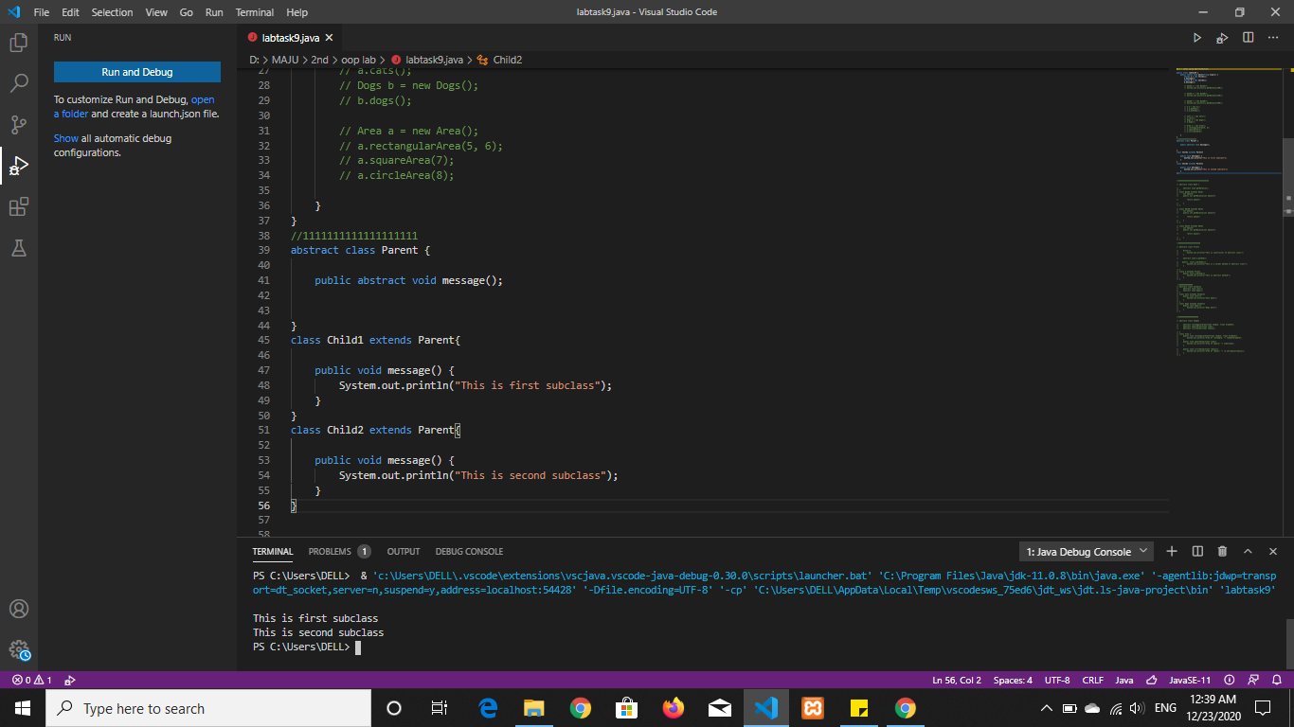

**Question 2/Task 2:**

Create an abstract class &#39;Bank&#39; with an abstract method &#39;getBalance&#39;. $100, $150 and $200

are deposited in banks A, B and C respectively. &#39;BankA&#39;, &#39;BankB&#39; and &#39;BankC&#39; are subclasses of class &#39;Bank&#39;, each having a method named &#39;getBalance&#39;. Call this method by creating an object of each of the three classes.

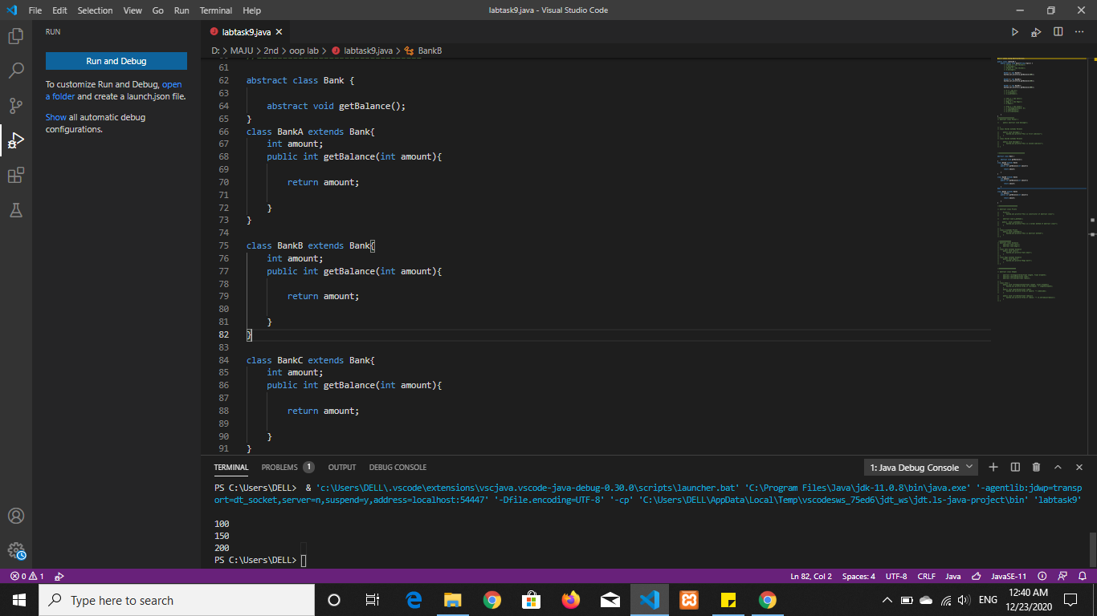

**Question 3/Task 3:**

An abstract class has a constructor which prints &quot;This is constructor of abstract class&quot;, an

abstract method named &#39;a_method&#39; and a non-abstract method which prints &quot;This is a normal

method of abstract class&quot;. A class &#39;SubClass&#39; inherits the abstract class and has a method

named &#39;a_method&#39; which prints &quot;This is abstract method&quot;. Now create an object of &#39;SubClass&#39;

and call the abstract method and the non-abstract method. (Analyze the result)

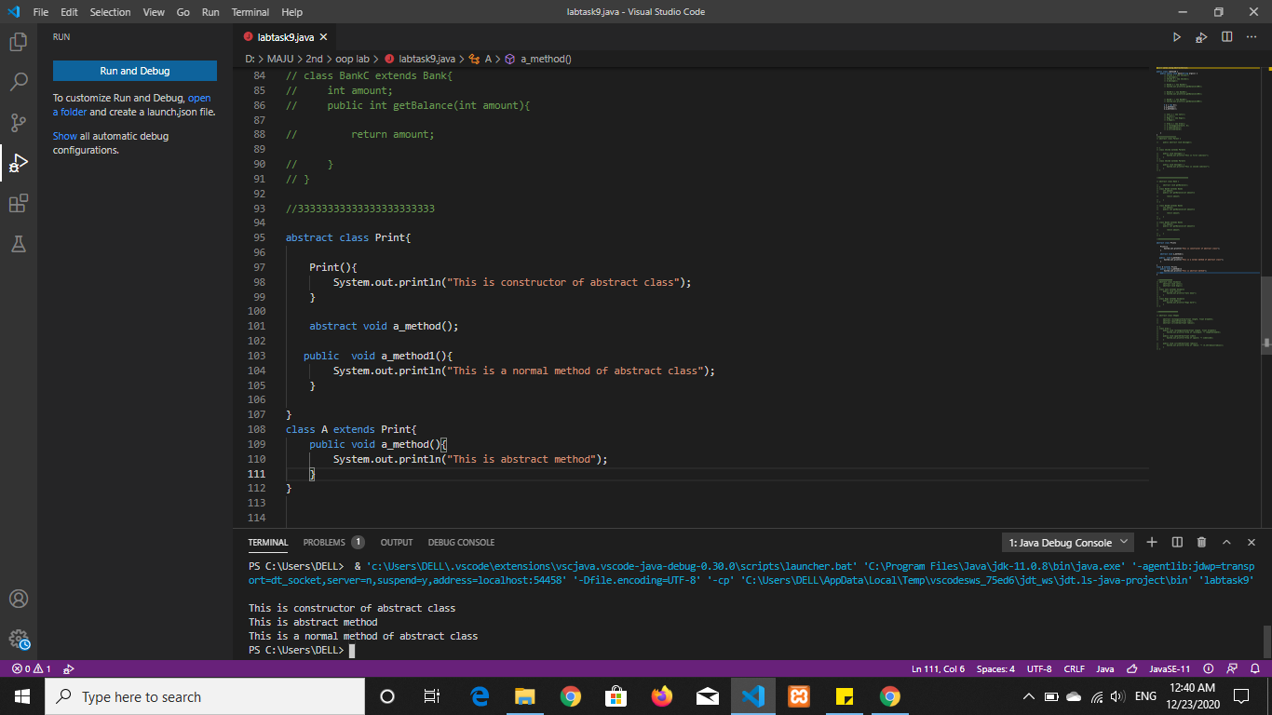

**Question 4/Task 4:**

Create an abstract class &#39;Animals&#39; with two abstract methods &#39;cats&#39; and &#39;dogs&#39;. Now create a class &#39;Cats&#39; with a method &#39;cats&#39; which prints &quot;Cats meow&quot; and a class &#39;Dogs&#39; with a method &#39;dogs&#39; which prints &quot;Dogs bark&quot;, both inheriting the class &#39;Animals&#39;. Now create an object for each of the subclasses and call their respective methods.

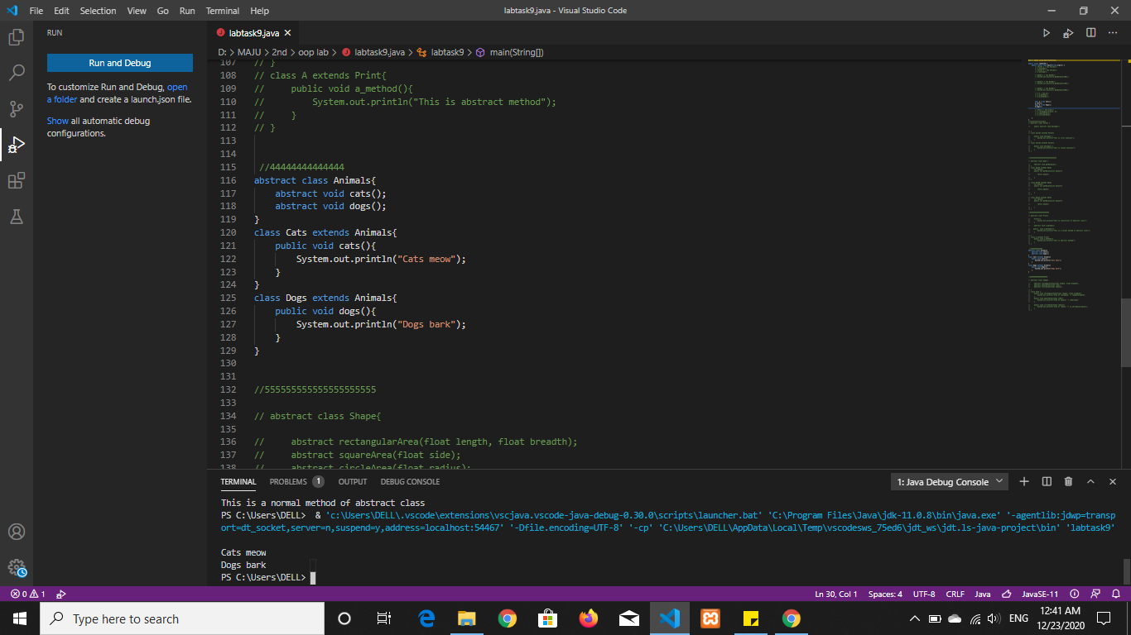

**Question 5/Task 5:**

We have to calculate the area of a rectangle, a square and a circle. Create an abstract class

&#39;Shape&#39; with three abstract methods namely &#39;RectangleArea&#39; taking two parameters,

&#39;SquareArea&#39; and &#39;CircleArea&#39; taking one parameter each. The parameters of &#39;RectangleArea&#39;are its length and breadth, that of &#39;SquareArea&#39; is its side and that of &#39;CircleArea&#39; is its radius. Now create another class &#39;Area&#39; containing all the three methods &#39;RectangleArea&#39;, &#39;SquareArea&#39; and &#39;CircleArea&#39; for printing the area of rectangle, square and circle respectively.

Create an object of class &#39;Area&#39; and call all the three methods.

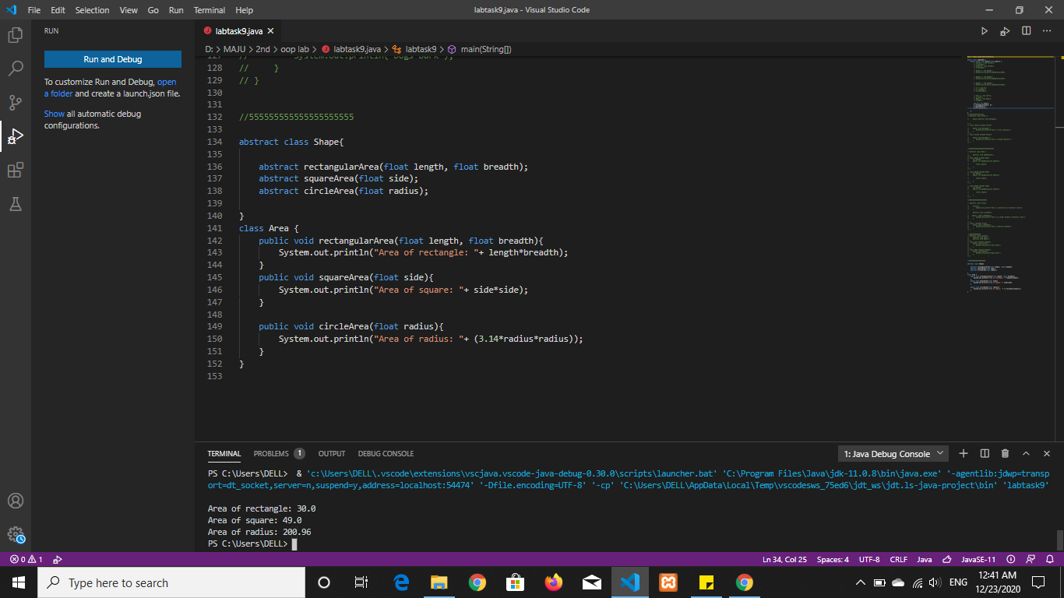

***Mohammad Ali Jinnah University***